About Python
Break down the image below into proper HTML and CSS.
Before you submit your work:
- Remember that you're here to learn: Don't try to find the original source code of these images.
- Make sure you've validated your HTML and that you're not using any float: left or right.
- For the ">>" on the list, don't worry about making it look exactly like >>. You can just use a normal circle for this assignment.
- Do NOT make this responsive. Just make this work for a fixed width (set the width to be 970px). You will go through our responsive design course later. For now, try to master the CSS principles for fixed width first.
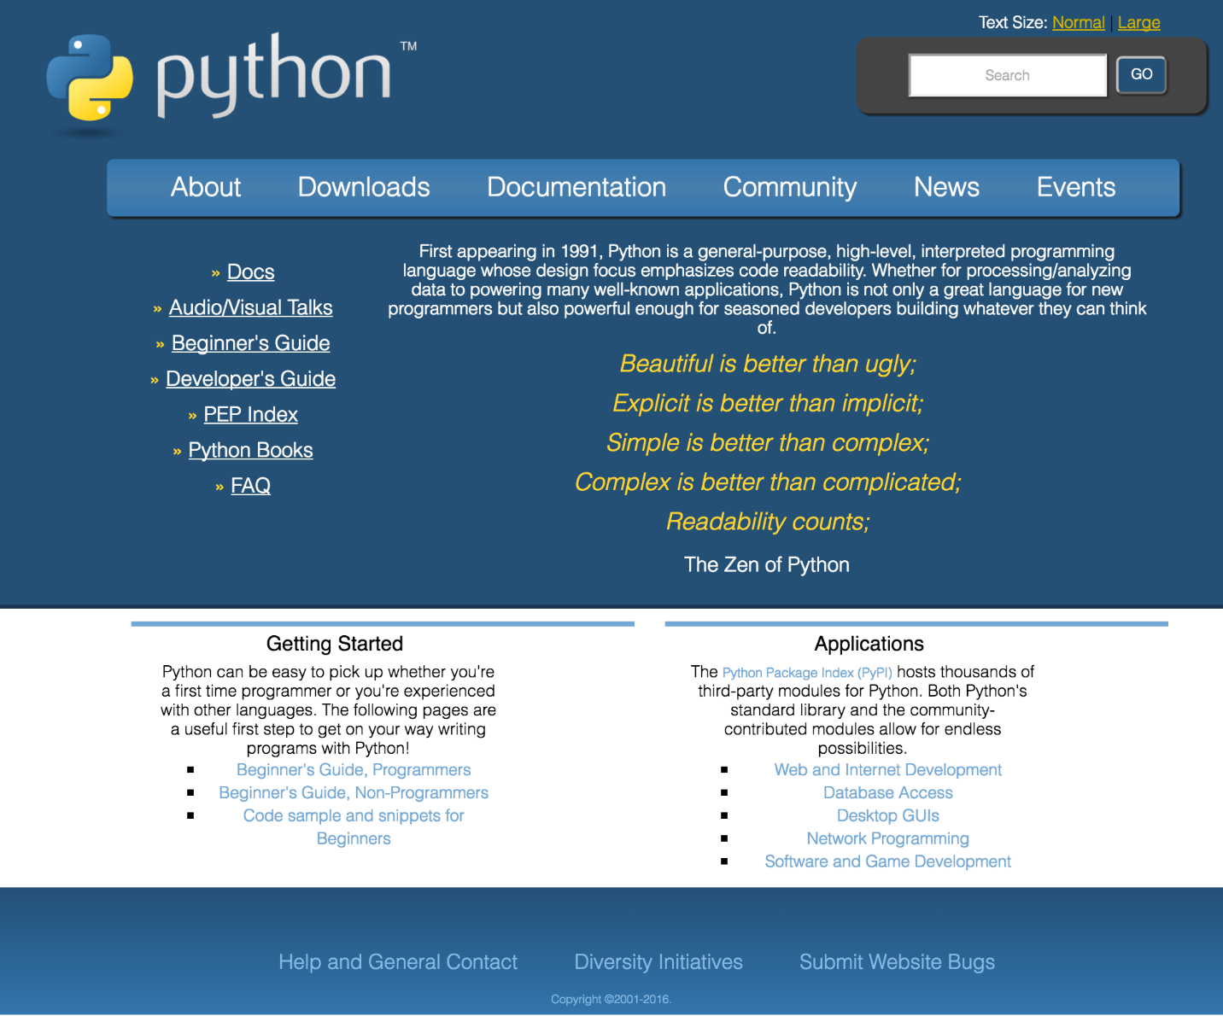

  - Work on the exercise above and upload your work here. You may put all your html, css files and images in a single folder and have it compressed before uploading.

